Octagrammic Cupola
# Source: AI Source: Provided by: [Data Path: Persons Table -> ID Column: 1, Name_En Column: Motasem Essam] -> From: [ChatGPT] on [7/25/2026]
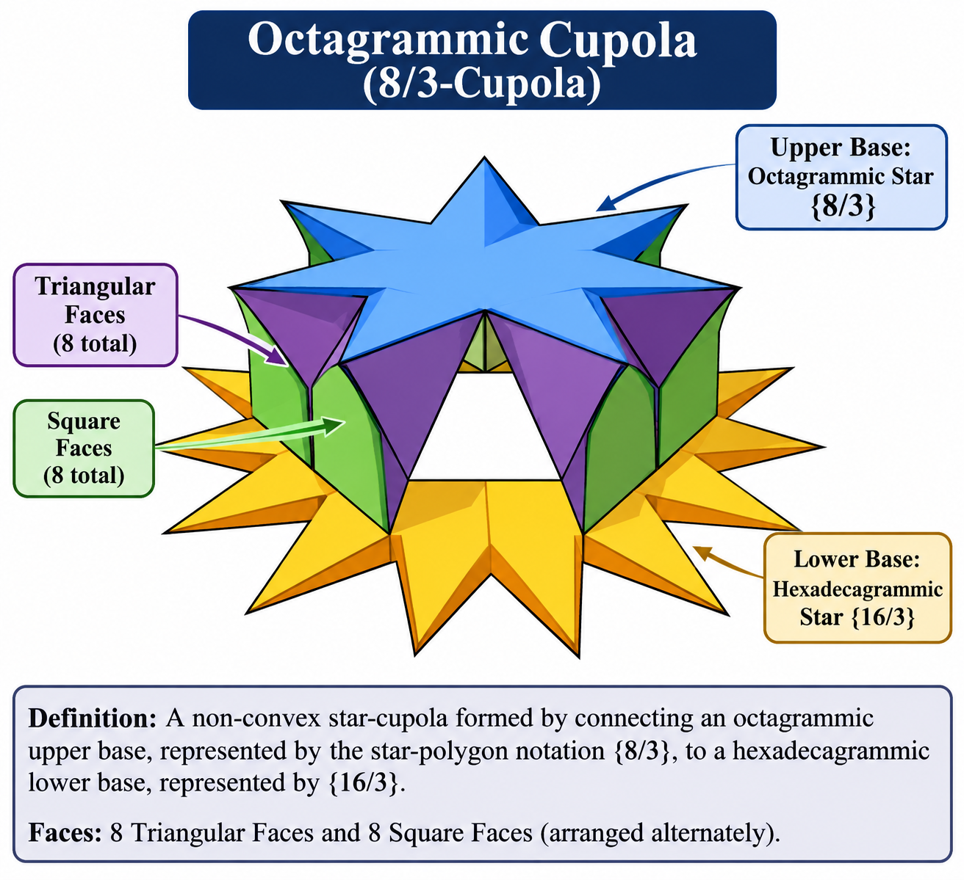

Definition
# Source: AI Source: Provided by: [Data Path: Persons Table -> ID Column: 1, Name_En Column: Motasem Essam] -> From: [ChatGPT] on [7/25/2026]
An Octagrammic Cupola, also known as an 8/3-Cupola, is a non-convex star-cupola formed by connecting an octagrammic upper base, represented by the star-polygon notation $\{8/3\}$, to a parallel hexadecagrammic lower base, represented by $\{16/3\}$.
Its lateral structure consists of eight equilateral triangular faces and eight square faces arranged alternately around the two star-polygon bases. <Cite refs={["turn283144search0","turn283144search3","turn283144search13"]}/>
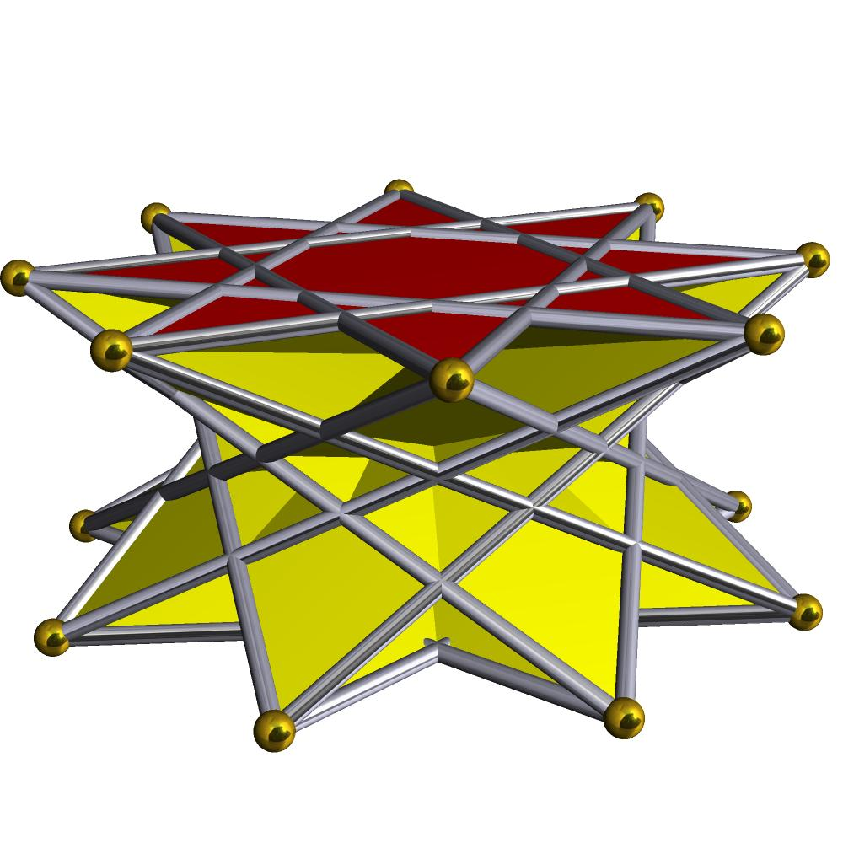

Geometric Structure
# Source: AI Source: Provided by: [Data Path: Persons Table -> ID Column: 1, Name_En Column: Motasem Essam] -> From: [ChatGPT] on [7/25/2026]
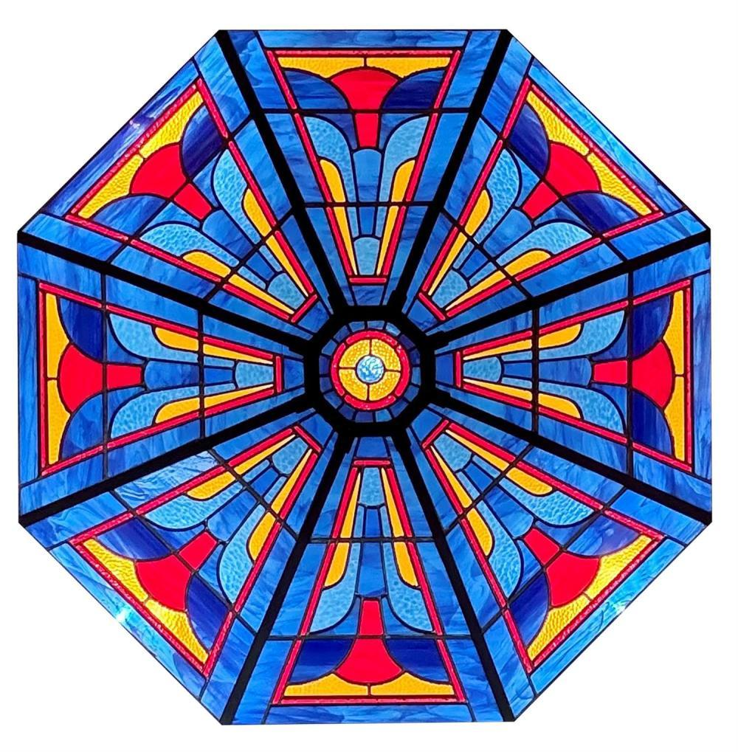
The Octagrammic Cupola consists of:
- Upper Base: An octagram represented by the star-polygon notation $\{8/3\}$.
- Lower Base: A hexadecagram represented by the star-polygon notation $\{16/3\}$.
- Triangular Faces: Eight equilateral triangular lateral faces.
- Square Faces: Eight square lateral faces.
- Star Arrangement: The lateral faces connect the two bases according to the octagram's vertex sequence.
<Cite refs={["turn283144search0","turn283144search6"]}/>

Face Composition
# Source: AI Source: Provided by: [Data Path: Persons Table -> ID Column: 1, Name_En Column: Motasem Essam] -> From: [ChatGPT] on [7/25/2026]
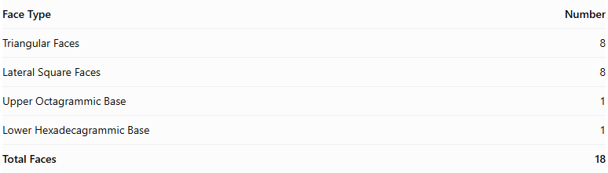
Face Type | Number
Triangular Faces | 8
Lateral Square Faces | 8
Upper Octagrammic Base | 1
Lower Hexadecagrammic Base | 1
Total Faces | 18
The two bases are star polygons, while the sixteen lateral faces form the connecting structure. <Cite refs={["turn283144search0","turn283144search6"]}/>

Mathematical Properties
# Source: AI Source: Provided by: [Data Path: Persons Table -> ID Column: 1, Name_En Column: Motasem Essam] -> From: [ChatGPT] on [7/25/2026]
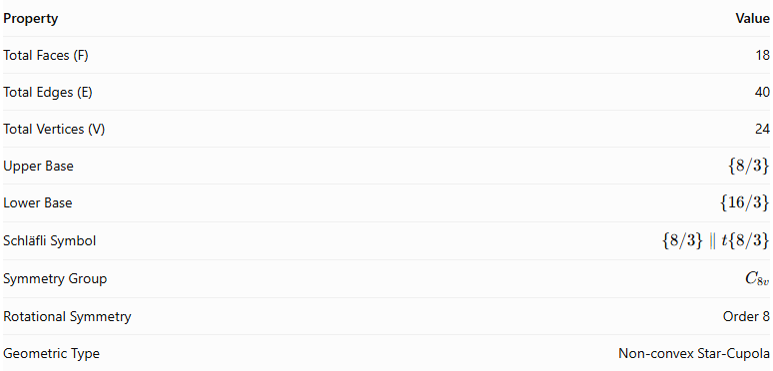
Property | Value
Total Faces (F) | 18
Total Edges (E) | 40
Total Vertices (V) | 24
Upper Base | $$\{8/3\}$$
Lower Base | $$\{16/3\}$$
Schläfli Symbol | $$\{8/3\}∥t\{8/3\}$$
Symmetry Group | $$C_{8v}$$
Rotational Symmetry | Order 8
Geometric Type | Non-convex Star-Cupola
<Cite refs={["turn283144search0","turn283144search6"]}/>
General Cupola Formulas:
$$F=2n+2, E=5n, V=3n$$
For $n=8$:
$$F=18, E=40, V=24$$
Euler's Polyhedron Formula:
$$V-E+F=2$$
$$24-40+18=2$$

Geometric Characteristics
# Source: AI Source: Provided by: [Data Path: Persons Table -> ID Column: 1, Name_En Column: Motasem Essam] -> From: [ChatGPT] on [7/25/2026]
- Non-Convex Structure: Its star-polygon bases produce a non-convex geometric arrangement.
- Octagrammic Upper Base: The upper base follows the $\{8/3\}$ vertex sequence, connecting every third vertex.
- Hexadecagrammic Lower Base: The lower base follows the $\{16/3\}$ star-polygon sequence.
- Eightfold Rotational Symmetry: Its structure repeats after a rotation of ${45}^{∘}$.
- Alternating Lateral Faces: Eight equilateral triangles and eight squares form the lateral structure.
- Star-Cupola Construction: It belongs to the family of star-cupolae, rather than ordinary convex cupolae.

Constructing Octagrammic Cupola in Solid Geometry

Geometric Instruments Used
# Source: AI Source: Provided by: [Data Path: Persons Table -> ID Column: 1, Name_En Column: Motasem Essam] -> From: [ChatGPT] on [7/25/2026]
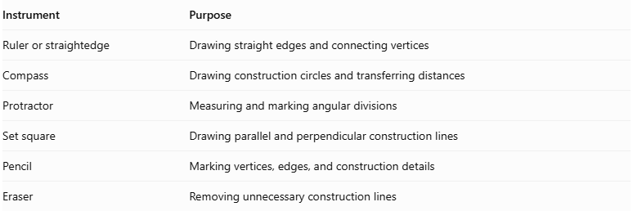
Instrument | Purpose
Ruler or straightedge | Drawing straight edges and connecting vertices
Compass | Drawing construction circles and transferring distances
Protractor | Measuring and marking angular divisions
Set square | Drawing parallel and perpendicular construction lines
Pencil | Marking vertices, edges, and construction details
Eraser | Removing unnecessary construction lines
Construction method: Instrument-based geometric construction using geometric instruments and measured angles. It does not use coordinate-based construction.

Instrument-Based Construction Procedures

Constructing the Upper Octagram
# Source: AI Source: Provided by: [Data Path: Persons Table -> ID Column: 1, Name_En Column: Motasem Essam] -> From: [ChatGPT] on [7/25/2026]
- Draw a circle using a compass.
- Mark eight equally spaced points around its circumference.
- Number the vertices consecutively from 1 to 8.
- Connect each vertex to the vertex three positions ahead, following the sequence:
- 1 → 4
- 2 → 5
- 3 → 6
- 4 → 7
- 5 → 8
- 6 → 1
- 7 → 2
- 8 → 3
- Complete the upper star polygon $\{8/3\}$.

Constructing the Lower Hexadecagram
# Source: AI Source: Provided by: [Data Path: Persons Table -> ID Column: 1, Name_En Column: Motasem Essam] -> From: [ChatGPT] on [7/25/2026]
- Draw a second circle for the lower base.
- Mark sixteen equally spaced points around its circumference.
- Number the vertices consecutively from 1 to 16.
- Connect each vertex to the vertex three positions ahead, wrapping around the numbering after vertex 16.
- Complete the lower star polygon $\{16/3\}$.

Positioning the Two Bases
# Source: AI Source: Provided by: [Data Path: Persons Table -> ID Column: 1, Name_En Column: Motasem Essam] -> From: [ChatGPT] on [7/25/2026]
- Draw the two bases as parallel planes in the intended three-dimensional representation.
- Position the octagram above the hexadecagram.
- Align their orientations according to the standard octagrammic cupola arrangement.
- Maintain the intended symmetry around the central axis.

Constructing the Lateral Faces
# Source: AI Source: Provided by: [Data Path: Persons Table -> ID Column: 1, Name_En Column: Motasem Essam] -> From: [ChatGPT] on [7/25/2026]
- Connect the corresponding vertices of the upper and lower star bases according to the cupola's face-adjacency pattern.
- Construct eight triangular lateral faces.
- Construct eight square lateral faces between the two base structures.
- Check that the lateral faces close around the solid without adding unintended connections.
- Distinguish visible edges from hidden edges.

Completing the Three-Dimensional Representation
# Source: AI Source: Provided by: [Data Path: Persons Table -> ID Column: 1, Name_En Column: Motasem Essam] -> From: [ChatGPT] on [7/25/2026]
- Darken the visible outer edges.
- Use dashed lines for hidden edges where necessary.
- Preserve the star-shaped arrangement of both bases.
- Check the eight-fold symmetry and the consistency of the lateral-face arrangement.
Construction accuracy note: A regular octagon can be constructed exactly with a compass and straightedge, but a regular 16-gon can also be constructed exactly by repeated angle bisection. A protractor may be used as an alternative for measured angular marking. The star polygons are formed by connecting every third vertex, not by connecting adjacent vertices.

Key Points
# Source: AI Source: Provided by: [Data Path: Persons Table -> ID Column: 1, Name_En Column: Motasem Essam] -> From: [ChatGPT] on [7/25/2026]
- Alternative Name: 8/3-Cupola.
- Upper Base: Octagram $\{8/3\}$.
- Lower Base: Hexadecagram $\{16/3\}$.
- Lateral Faces: 8 Triangles and 8 Squares.
- Total Faces: 18.
- Total Edges: 40.
- Total Vertices: 24.
- Rotational Symmetry: Order 8.
- Classification: Non-convex Star-Cupola.

Main Classification
# Source: AI Source: Provided by: [Data Path: Persons Table -> ID Column: 1, Name_En Column: Motasem Essam] -> From: [ChatGPT] on [7/25/2026]
Solid Geometry
└── Types of Solids
└── Star-Cupola
└── Types of Star-Cupola
└── Octagrammic Cupola

Conclusion
# Source: AI Source: Provided by: [Data Path: Persons Table -> ID Column: 1, Name_En Column: Motasem Essam] -> From: [ChatGPT] on [7/25/2026]
The Octagrammic Cupola is a non-convex star-cupola characterized by its octagrammic upper base, hexadecagrammic lower base, and alternating triangular and square lateral faces. It has 18 faces, 40 edges, and 24 vertices, with eightfold rotational symmetry.
Important distinction: The Octagrammic Cupola $\{8/3\}$ is different from the Crossed Octagrammic Cupola $\{8/5\}$. They are separate members of the star-cupola family. <Cite refs={["turn283144search0","turn283144search13"]}/>

